PhD Viva Voce
Candidate Name: | Juliana L. Bachilula | 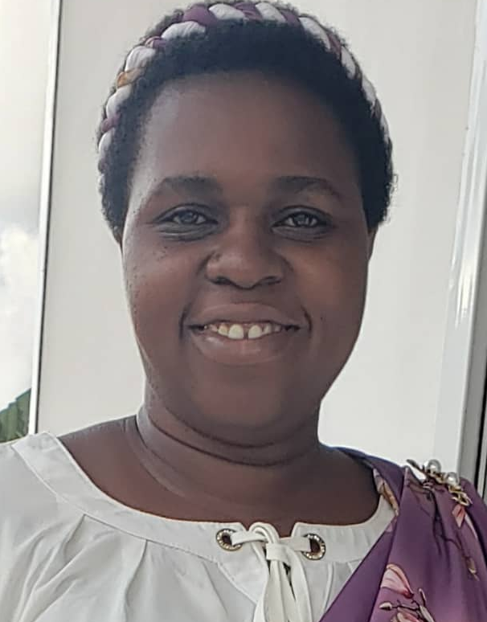
Registration Number: | 2018-07-00220
 | University of Dar es Salaam
 | School of Education

Qualifications Attained:
Ms. Juliana is a PhD candidate (by Thesis) in the Department of Educational Foundation Management and Lifelong Learning, School of Education at the University of Dar es Salaam (UDSM). She also works at the School of Education as an assistant lecturer. The same university awarded Ms. Juliana a Master's degree in Educational Management and Administration in 2014. Ms. Juliana teaches a variety of educational management courses, including Management of Education and School Administration, Human Resource Development in Educational Organization and Administrative and Organizational Behavior in Education. With a qualitative research orientation, Ms. Juliana research interests include gender and leadership in higher education institutions.
Title of Thesis: | Lived Experiences of Female Academics in Leadership: Selected Examples from Public Universities in Tanzania
Date of Viva Voce: | 24th October, 2023
Venue: | Board Room-SoED
Time: | 10: 00a.m
Supervisors: | Dr. Hillary Dachi and Dr. Boniface Raymond

Abstract:
This study explored the lived experiences of female academics in leadership from selected public universities in Tanzania. The study had three specific objectives. First, to examine the process through which the female academics become leaders at the University of Dar es Salaam and State University of Zanzibar. The second objective was to determine the strategies used by the female academics in balancing their leadership roles and other responsibilities and the third objective was to assess the views of female top management leaders concerning female academics who serve as leaders based on the way they perform their responsibilities effectively and how they empower other female academics aspiring for leadership positions. The liberal feminist theoretical perspective and the social justice leadership theory guided the study. The study adopted a qualitative research approach and hermeneutic phenomenology research design that aimed to help one to understand the leadership experiences of female academic leaders at UDSM and SUZA. Purposive sampling and snowball sampling techniques were used in selecting research sites and study participants. The sample consisted of 31 research participants, comprising seventeen continuing university female academic leaders, ten former university female academic leaders and four university female top management leaders. The data for this study were collected through semi-structured interviews and documentary reviews. They were analysed using interpretive phenomenological and content analysis. The findings showed the following. Firstly, it was established that female academic leaders at UDSM and SUZA had a vast scope of leadership experiences. The skills obtained from leadership capacity building, accountability and teamwork were embraced by female academics, which enabled them to remain in their leadership positions. Secondly, it was found that female academic leaders applied three baskets, the religious principle and resilience strategies in balancing their leadership roles and other responsibilities. However, findings showed that female academic leaders experienced negative attitudes from their fellow female academic leaders as they were reported to have disliked being challenged by their fellow female academic leaders. Thirdly, university female top management leaders had a positive view of female academic leadership as hard-working, committed, and honest with their job. The study concludes that the transformation of mindset was the strategy used by female top management leaders to adjust and readjust female academics’ thinking about their participation in the university leadership positions as well as changing their social inequalities constructed by female academics themselves. It is recommended that other studies be done to examine the implications of the female leadership and the magnitude of the impact to the females, the colonial legacy, socio-cultural practices and faith based community leaders have in depriving female participation in leadership.

Panel Members
No | Name | Designation | Rank | Unit
 | Prof. Abel Ishumi | Chairperson | Professor Emeritus | SoED-EFMLL
 | Dr. Gennes Shirima | Representing External Examiner | S/Lecturer | SoED-EFMLL
 | Prof. Eustella Bhalalusesa | Internal Examiner | Professor | SoED-EFMLL
 | Dr. Hillary Dachi | Candidate’s Supervisor | S/Lecturer | SoED-EFMLL
 | Dr. Nkanileka Mgonda | Head of the relevant department (or his/her appointee) | S/Lecturer | SoED-EFMLL
 | Dr. Lulu Mahai | Co-opted Member (appointed by College/School/Institute | S/Lecturer | SoED-EFMLL
 | Dr. Albert Tarmo | Co-opted Member (appointed by College/School/Institute | S/Lecturer | SoED-EPCS
 | Dr. Perpetua Urio | Appointee of the Principal for PhD only) | S/Lecturer | DUCE-EFMLL

